Inventory Tracker  
Maintenance and User Guides

# Maintenance Guide

1. Download and extract the folder containing the source code and .apk file.
   1. The .apk file will need to be copied/moved to an Android device for testing.
      1. If cannot be moved to Android device, download .apk file here: <https://1drv.ms/u/s!Agk0Yx374fb3gedlKe4zw3xzhdMkOg?e=CWlJFA>  
         and follow each prompt and warning, always selecting to continue with installing the application.
   2. Once on Android device, file needs to be found and launched to install the application.
      1. Check for install confirmation notification.
      2. Otherwise, find file in recent downloads folder and launch it.
      3. Follow prompts to INSTALL the application.
      4. Launch
2. If testing from source code, rather than .apk file:
   1. Make sure that your copy of Visual Studio has the “Mobile development with .NET” workload installed (<https://dotnet.microsoft.com/learn/xamarin/hello-world-tutorial/install> ).
   2. Either Android emulator can be used ( <http://www.techbubbles.com/visual-studio-2019/android-emulator-setup-tip-visual-studio/> ).
   3. Or Android device can be used (<https://docs.microsoft.com/en-us/xamarin/android/get-started/installation/set-up-device-for-development> ).
3. If you run into any issues with the database and would like a fresh start, simple navigate to \InventoryTracker\App.xaml.cs line 27 and change the “InventoryDB.db3” string at the end of the line to another value ending in “.db3”.

# User Guide

The purpose of this application is to provide an organizational structure in which to organize material, conceptual, or imaginary objects in a navigable and searchable hierarchal structure. Input objects to be located, moved, modified, or removed based on their real-world states. This application is intentionally designed to be open-ended to allow for any kind of uses, ranging from personal items, to imaginary tabletop game inventories, to keeping track of projects and work items. Enjoy!

Figure 1.1:   
Upon application startup, you will be presented with a login/signup page. On first use, check “Create new account” to create a new account with the input Username and Password. You do not need to check that when logging in with an existing account. If you have not logged out of your previous session, the application will automatically redirect you to the User view.

Figure 1.2:   
Once logged in, tapping the “Hamburger” menu button in the top-left corner will open the menu. (Starting from the top) “Global search…” input allows you to search for items by keyword, phrase, or even characters, numbers, or fragments of words.  
Below that, the Object hierarchy (breadcrumb trail) is used to navigate to higher tier parent items relative to the currently viewed item. Tap one of the items to navigate to its corresponding Object view. The trail will grow and shrink as you navigate the application.  
“Statistics” and “Settings” redirect to User statistics (Figure 3.2) and User settings, respectively.  
“Logout” logs out the user and redirects to the Login/Signup Page (Figure 1.1).

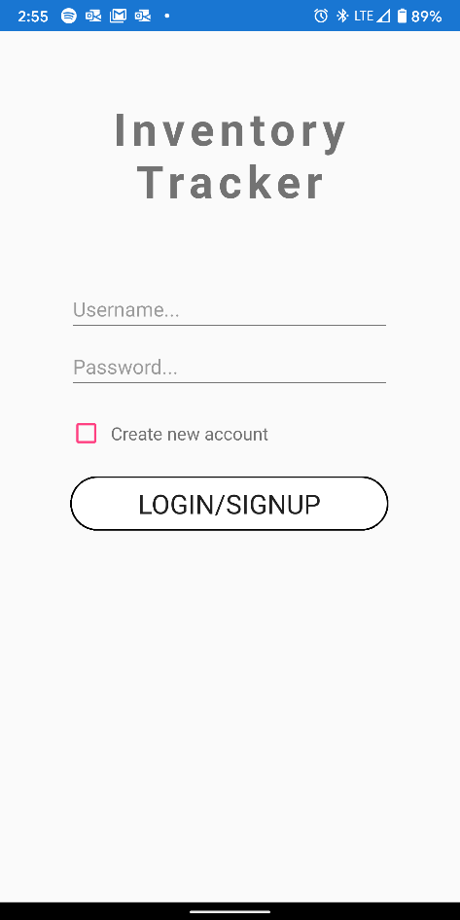 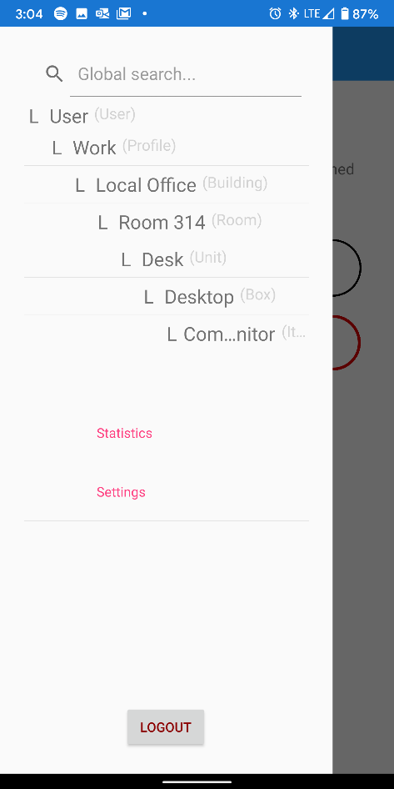

Figure 1 (Login/Signup Page & Hamburger Menu)

Figure 2.1:  
This is the User view. The “Current object search…” redirects to the Search Options page (Figure 4.1).   
“Edit” allows you to modify the attributes of the object.  
“Statistics” redirects to the Statistics view (Figure 3.2).  
After receiving an additional confirmation, “Delete” deletes the current object AND ALL ITS CHILDREN! Use with caution.  
“Add profile” redirects to the Add Object page (Figure 2.2).  
Below that is a list of the User’s Profiles, which can be selected to navigate to their respective views.

## Figure 2.2:

This is the page where you can add new objects. Simply fill in the Name and Description fields and the optional (only available for Items) Expiration Reminder and tap “Save” to save. Cancel redirects back to the previous page.

## Figure 2.3:

This is the [Item, Box, Unit, etc.] view. It has most of the same features (depending on type) as User, except the “Move” button, which redirects to a new page (Figure 3.3) that allows you to logically change the location (parent) of the current object.

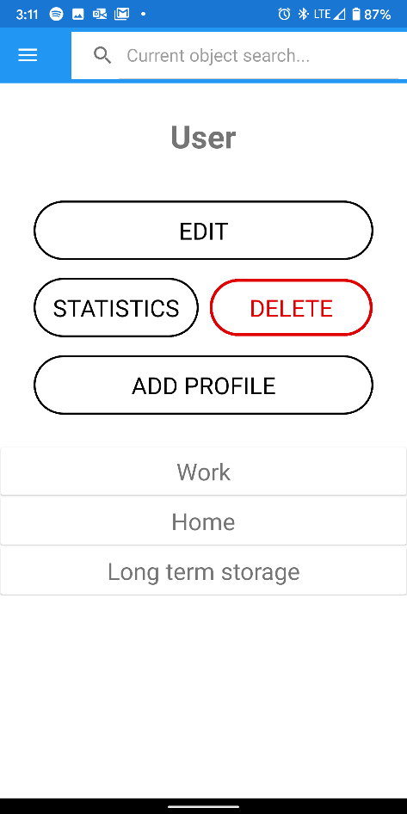 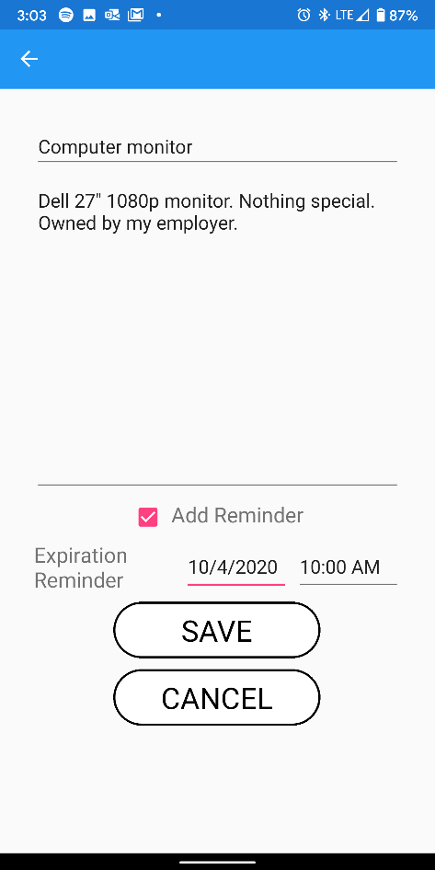 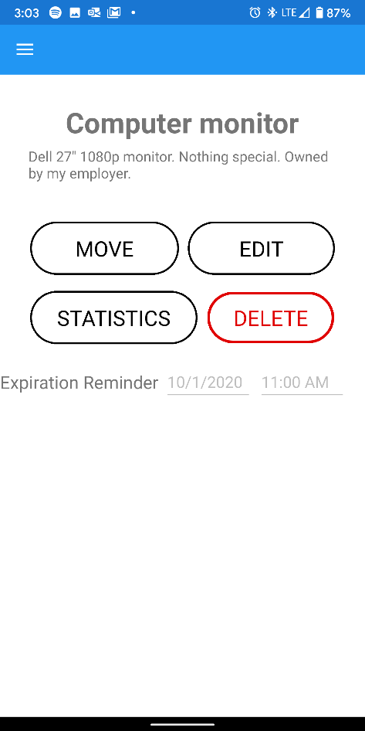

Figure 2 (User view, Add Item view, Item view)

## Figure 3.1:

This is an example of the Box view. It is different in that it allows storage of two types of objects: other Boxes and Items.

## Figure 3.2:

This page displays the statistics about the associated object, such as Name, Type (tier), ID, Date Created, Date Last Change was made, and a list of the number of each type of child object.

## Figure 3.3:

Displays a list of expandable items into which you can move the current object. If an object has children, tapping it will display them. Otherwise, pressing select will move the current object into the selected object. Objects can belong only to specific types of other objects (e.g. Boxes belong within other Boxes or Units, Buildings belong under Profiles, etc.). Profiles cannot be moved, therefore Users do not show up in the list.

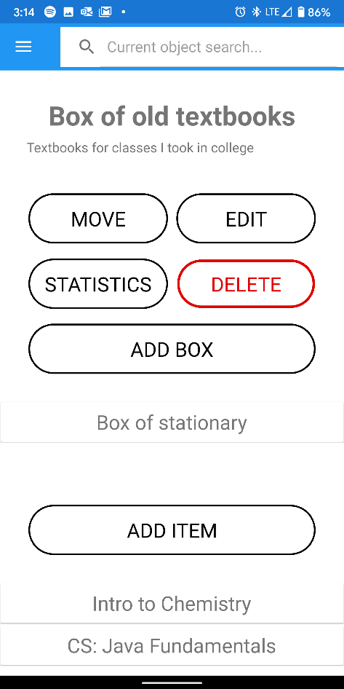 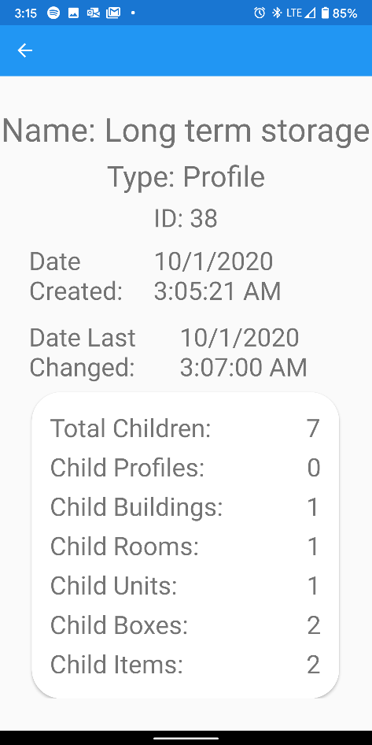 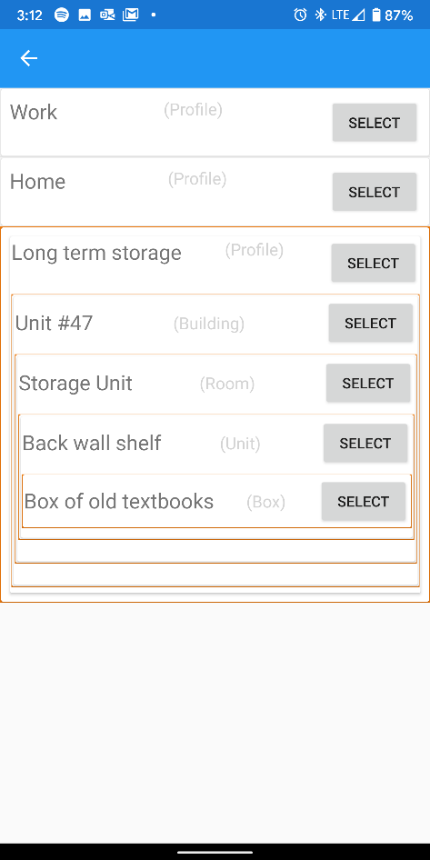

Figure 3 (Box view, Object Statistics, Move Object view)

## Figure 4.1:

1. Enter text in the top input form.
2. Select “Global search” or “Local search”. Global searches the entire inventory, whereas local searches only within the descendants of the current (previous viewed) object.
3. Select a “Sort By” option.
4. Check the attributes you would like to search within.
5. “Search” redirects to Search Results {Figure 4.2).

## Figure 4.2:

Count and results of the previous search. Items can be selected to redirect to its view.

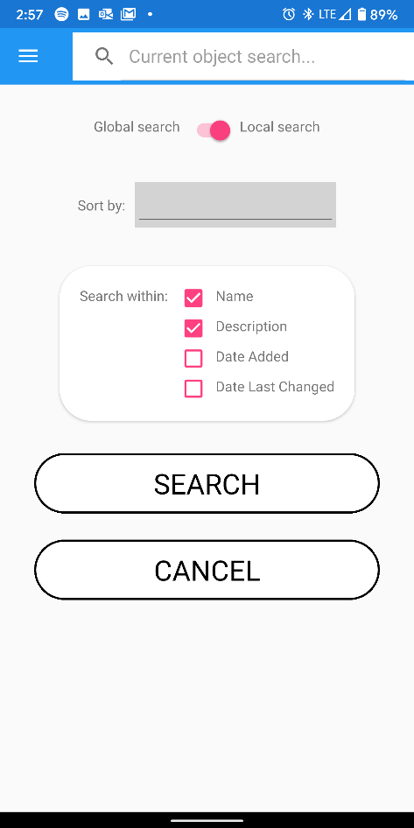 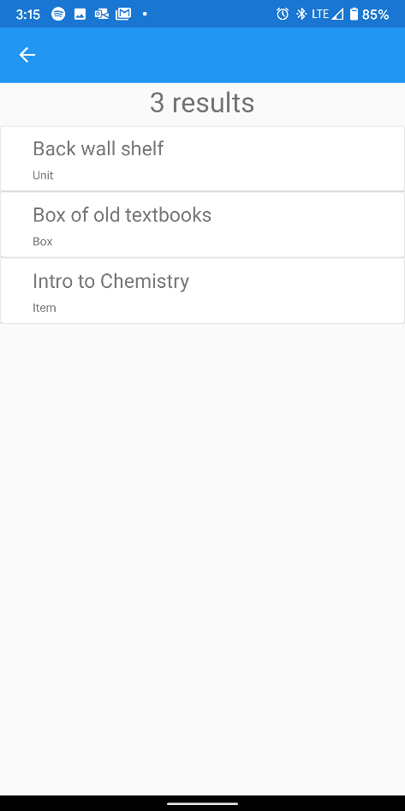

Figure 4 (Search Options & Search Results)